巨量資料 HW3

108062566 資工碩一 陳法佑

一、演算法  
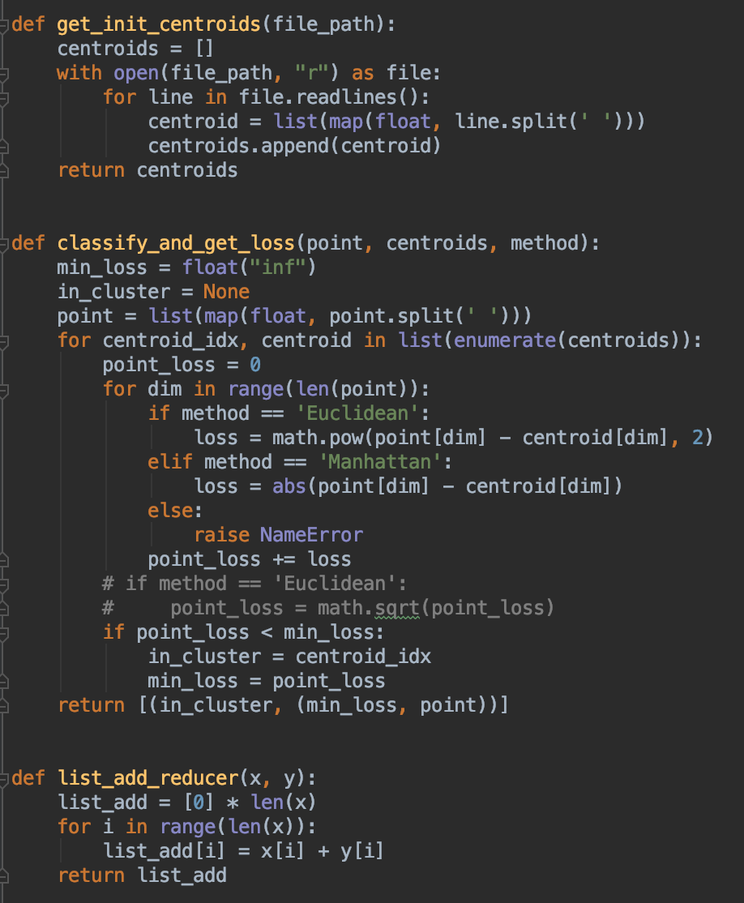  
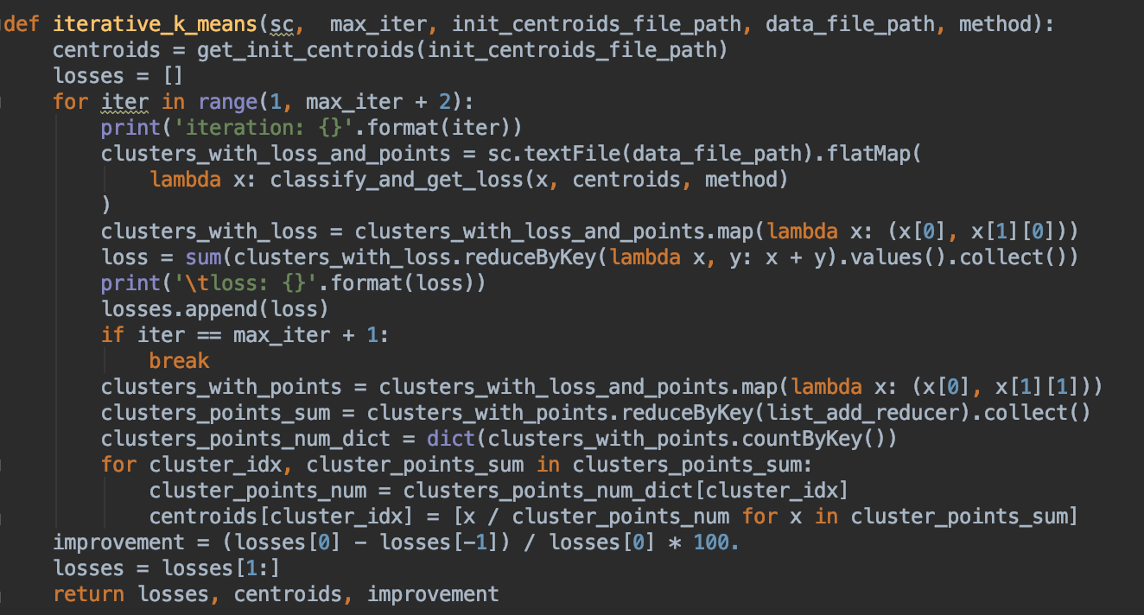

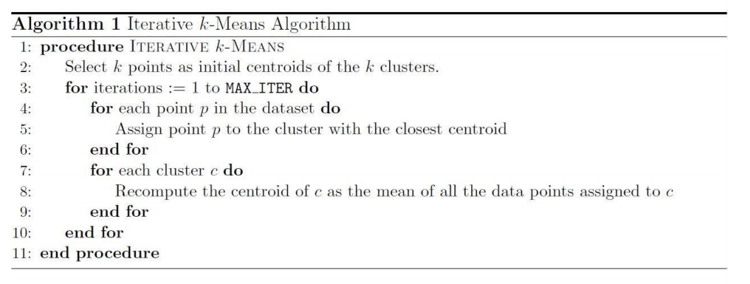

參考講義上的演算法進行實作，流程如下：

1. 從 “data.txt” 讀取所有點，並在此時計算每個點歸類到哪個 cluster 同時保存 loss，形式為 (in_cluster, (min_loss, point))，其中 in_cluster 表示此點被歸類在哪一個 cluster，min_loss 表示其與該 cluster 的 loss，point表示此點的座標。

2. 將在同一個 cluster 的 points reduce，把他們的座標相加之後除以在同一個 cluster 裡的 points 總數（在實作中為 “clusters_with_points.countByKey()”），算出來的 list 便是各個 centroids 的新的座標，接著便回到第一步重複執行步驟。值得注意的是，實作中讓迴圈跑了 21 次，因為第一次是 initial（centroids 尚未更新），算出來的loss 並不會記錄到圖片中，而第 21 次時算完 loss（也就是第 (1) 步時）就 break掉。

二、實驗數據

（2 - 1）loss 紀錄圖

Manhattan

*   
    
  Euclidean  
  

(2 - 2) 與 centroids 距離圖

**Loss Function：Euclidean**

Distance Function: c1_Euclidean

|  |  |  |  |  |  |  |  |  |  |  |
| --- | --- | --- | --- | --- | --- | --- | --- | --- | --- | --- |
| **Euclidean** | **1** | **2** | **3** | **4** | **5** | **6** | **7** | **8** | **9** | **10** |
| **1** | 0.0 | 692.16 | 3490.26 | 205.75 | 346.72 | 512.61 | 444.73 | 566.2 | 1282.77 | 307.67 |
| **2** |  | 0.0 | 2798.8 | 897.66 | 1038.83 | 1204.08 | 1136.33 | 1257.45 | 669.89 | 412.08 |
| **3** |  |  | 0.0 | 3695.11 | 3836.91 | 4002.69 | 3934.87 | 4056.14 | 2294.58 | 3195.92 |
| **4** |  |  |  | 0.0 | 142.44 | 309.51 | 241.73 | 363.26 | 1474.95 | 504.63 |
| **5** |  |  |  |  | 0.0 | 167.15 | 99.55 | 220.9 | 1615.85 | 646.93 |
| **6** |  |  |  |  |  | 0.0 | 67.91 | 53.79 | 1782.2 | 814.08 |
| **7** |  |  |  |  |  |  | 0.0 | 121.63 | 1715.25 | 746.34 |
| **8** |  |  |  |  |  |  |  | 0.0 | 1835.64 | 867.82 |
| **9** |  |  |  |  |  |  |  |  | 0.0 | 975.32 |
| **10** |  |  |  |  |  |  |  |  |  | 0.0 |

Distance Function: c2_Euclidean

|  |  |  |  |  |  |  |  |  |  |  |
| --- | --- | --- | --- | --- | --- | --- | --- | --- | --- | --- |
| **Euclidean** | **1** | **2** | **3** | **4** | **5** | **6** | **7** | **8** | **9** | **10** |
| **1** | 0.0 | 15760.12 | 14110.83 | 9045.32 | 5567.68 | 1924.62 | 1100.86 | 402.89 | 2105.44 | 3169.0 |
| **2** |  | 0.0 | 11524.51 | 6743.88 | 10192.53 | 14455.12 | 14682.45 | 15362.42 | 13674.71 | 12597.04 |
| **3** |  |  | 0.0 | 9545.88 | 10883.38 | 12233.96 | 13208.0 | 13786.48 | 12508.96 | 11938.38 |
| **4** |  |  |  | 0.0 | 3494.22 | 7718.22 | 7957.78 | 8644.81 | 6947.82 | 5876.33 |
| **5** |  |  |  |  | 0.0 | 4404.56 | 4492.46 | 5169.94 | 3488.16 | 2407.92 |
| **6** |  |  |  |  |  | 0.0 | 1182.86 | 1615.79 | 1313.33 | 2153.77 |
| **7** |  |  |  |  |  |  | 0.0 | 698.49 | 1010.2 | 2085.46 |
| **8** |  |  |  |  |  |  |  | 0.0 | 1702.79 | 2768.61 |
| **9** |  |  |  |  |  |  |  |  | 0.0 | 1080.53 |
| **10** |  |  |  |  |  |  |  |  |  | 0.0 |

Distance Function: c1_Manhattan

|  |  |  |  |  |  |  |  |  |  |  |
| --- | --- | --- | --- | --- | --- | --- | --- | --- | --- | --- |
| **Manhattan** | **1** | **2** | **3** | **4** | **5** | **6** | **7** | **8** | **9** | **10** |
| **1** | 0.0 | 728.92 | 3797.9 | 212.18 | 374.89 | 577.4 | 499.16 | 645.77 | 1731.06 | 406.7 |
| **2** |  | 0.0 | 3072.89 | 935.89 | 1100.83 | 1303.9 | 1225.35 | 1372.09 | 1005.29 | 490.93 |
| **3** |  |  | 0.0 | 4001.04 | 4170.3 | 4372.79 | 4294.95 | 4440.72 | 2513.42 | 3396.42 |
| **4** |  |  |  | 0.0 | 171.37 | 375.25 | 296.25 | 443.5 | 1934.09 | 609.75 |
| **5** |  |  |  |  | 0.0 | 204.52 | 125.6 | 272.93 | 2102.86 | 779.4 |
| **6** |  |  |  |  |  | 0.0 | 79.4 | 69.59 | 2306.38 | 983.02 |
| **7** |  |  |  |  |  |  | 0.0 | 147.87 | 2227.56 | 904.37 |
| **8** |  |  |  |  |  |  |  | 0.0 | 2374.55 | 1050.92 |
| **9** |  |  |  |  |  |  |  |  | 0.0 | 1327.58 |
| **10** |  |  |  |  |  |  |  |  |  | 0.0 |

Distance Function: c2_Manhattan

|  |  |  |  |  |  |  |  |  |  |  |
| --- | --- | --- | --- | --- | --- | --- | --- | --- | --- | --- |
| **Manhattan** | **1** | **2** | **3** | **4** | **5** | **6** | **7** | **8** | **9** | **10** |
| **1** | 0.0 | 15772.61 | 20215.65 | 9533.17 | 5604.2 | 3088.05 | 1311.04 | 471.27 | 2369.41 | 3349.66 |
| **2** |  | 0.0 | 16003.5 | 7219.2 | 10221.03 | 16105.35 | 14909.17 | 15434.46 | 13950.58 | 12776.88 |
| **3** |  |  | 0.0 | 10690.48 | 14613.55 | 17509.9 | 18912.61 | 19748.94 | 17851.81 | 16873.24 |
| **4** |  |  |  | 0.0 | 3935.29 | 8896.39 | 8228.36 | 9065.4 | 7168.73 | 6190.68 |
| **5** |  |  |  |  | 0.0 | 5893.07 | 4696.98 | 5221.25 | 3737.71 | 2564.17 |
| **6** |  |  |  |  |  | 0.0 | 1781.82 | 2619.81 | 2162.8 | 3337.75 |
| **7** |  |  |  |  |  |  | 0.0 | 840.72 | 1068.94 | 2137.79 |
| **8** |  |  |  |  |  |  |  | 0.0 | 1901.21 | 2883.73 |
| **9** |  |  |  |  |  |  |  |  | 0.0 | 1176.45 |
| **10** |  |  |  |  |  |  |  |  |  | 0.0 |

**Loss Function：Manhattan**

Distance Function: c1_Euclidean

|  |  |  |  |  |  |  |  |  |  |  |
| --- | --- | --- | --- | --- | --- | --- | --- | --- | --- | --- |
| **Euclidean** | **1** | **2** | **3** | **4** | **5** | **6** | **7** | **8** | **9** | **10** |
| **1** | 0.0 | 2219.18 | 9948.04 | 528.7 | 413.37 | 827.72 | 681.03 | 917.13 | 832.15 | 729.06 |
| **2** |  | 0.0 | 7767.95 | 2734.05 | 2628.49 | 3044.48 | 2898.71 | 3133.46 | 1812.45 | 1491.36 |
| **3** |  |  | 0.0 | 10433.06 | 10361.37 | 10773.53 | 10626.49 | 10862.97 | 9340.28 | 9236.84 |
| **4** |  |  |  | 0.0 | 221.37 | 375.16 | 249.38 | 457.26 | 1156.58 | 1251.16 |
| **5** |  |  |  |  | 0.0 | 415.99 | 270.75 | 505.07 | 1171.96 | 1137.14 |
| **6** |  |  |  |  |  | 0.0 | 147.05 | 89.49 | 1529.46 | 1553.12 |
| **7** |  |  |  |  |  |  | 0.0 | 236.51 | 1391.55 | 1407.4 |
| **8** |  |  |  |  |  |  |  | 0.0 | 1613.56 | 1642.13 |
| **9** |  |  |  |  |  |  |  |  | 0.0 | 709.41 |
| **10** |  |  |  |  |  |  |  |  |  | 0.0 |

Distance Function: c2_Euclidean

|  |  |  |  |  |  |  |  |  |  |  |
| --- | --- | --- | --- | --- | --- | --- | --- | --- | --- | --- |
| **Euclidean** | **1** | **2** | **3** | **4** | **5** | **6** | **7** | **8** | **9** | **10** |
| **1** | 0.0 | 15747.23 | 14100.14 | 9032.33 | 5554.79 | 2006.7 | 1338.16 | 514.63 | 1571.24 | 3022.66 |
| **2** |  | 0.0 | 11524.51 | 6743.88 | 10192.53 | 14474.55 | 14412.06 | 15239.88 | 14328.23 | 12731.4 |
| **3** |  |  | 0.0 | 9545.88 | 10883.38 | 12167.79 | 13125.35 | 13684.61 | 12643.99 | 12006.39 |
| **4** |  |  |  | 0.0 | 3494.22 | 7742.63 | 7694.28 | 8521.2 | 7588.4 | 6009.82 |
| **5** |  |  |  |  | 0.0 | 4452.97 | 4219.76 | 5047.52 | 4167.64 | 2542.57 |
| **6** |  |  |  |  |  | 0.0 | 1405.11 | 1637.73 | 910.99 | 2124.26 |
| **7** |  |  |  |  |  |  | 0.0 | 827.84 | 566.55 | 1684.52 |
| **8** |  |  |  |  |  |  |  | 0.0 | 1081.38 | 2511.46 |
| **9** |  |  |  |  |  |  |  |  | 0.0 | 1649.39 |
| **10** |  |  |  |  |  |  |  |  |  | 0.0 |

Distance Function: c1_Manhattan

|  |  |  |  |  |  |  |  |  |  |  |
| --- | --- | --- | --- | --- | --- | --- | --- | --- | --- | --- |
| **Manhattan** | **1** | **2** | **3** | **4** | **5** | **6** | **7** | **8** | **9** | **10** |
| **1** | 0.0 | 2341.02 | 11929.3 | 651.19 | 496.33 | 947.74 | 770.74 | 1056.8 | 1260.51 | 737.71 |
| **2** |  | 0.0 | 9597.44 | 2778.95 | 2830.14 | 3280.36 | 3104.29 | 3388.98 | 2380.46 | 1605.27 |
| **3** |  |  | 0.0 | 12323.29 | 12421.26 | 12871.48 | 12695.55 | 12979.13 | 10775.94 | 11196.79 |
| **4** |  |  |  | 0.0 | 335.95 | 558.47 | 382.46 | 667.53 | 1653.83 | 1379.17 |
| **5** |  |  |  |  | 0.0 | 452.86 | 276.33 | 561.85 | 1755.11 | 1226.66 |
| **6** |  |  |  |  |  | 0.0 | 177.59 | 110.22 | 2205.31 | 1677.67 |
| **7** |  |  |  |  |  |  | 0.0 | 287.43 | 2028.9 | 1500.99 |
| **8** |  |  |  |  |  |  |  | 0.0 | 2314.67 | 1786.81 |
| **9** |  |  |  |  |  |  |  |  | 0.0 | 1006.37 |
| **10** |  |  |  |  |  |  |  |  |  | 0.0 |

Distance Function: c2_Manhattan

|  |  |  |  |  |  |  |  |  |  |  |
| --- | --- | --- | --- | --- | --- | --- | --- | --- | --- | --- |
| **Manhattan** | **1** | **2** | **3** | **4** | **5** | **6** | **7** | **8** | **9** | **10** |
| **1** | 0.0 | 15757.69 | 20200.26 | 9517.67 | 5588.85 | 3281.49 | 1430.21 | 602.95 | 2102.55 | 3211.46 |
| **2** |  | 0.0 | 16003.5 | 7219.2 | 10221.03 | 16325.27 | 14506.49 | 15335.96 | 14980.06 | 12922.93 |
| **3** |  |  | 0.0 | 10690.48 | 14613.55 | 17521.52 | 18775.12 | 19602.26 | 18111.89 | 16995.13 |
| **4** |  |  |  | 0.0 | 3935.29 | 9116.02 | 8090.51 | 8918.81 | 7771.22 | 6312.53 |
| **5** |  |  |  |  | 0.0 | 6110.83 | 4293.5 | 5123.07 | 4768.92 | 2710.06 |
| **6** |  |  |  |  |  | 0.0 | 1855.58 | 2682.57 | 1358.8 | 3413.04 |
| **7** |  |  |  |  |  |  | 0.0 | 833.43 | 674.83 | 1784.51 |
| **8** |  |  |  |  |  |  |  | 0.0 | 1500.82 | 2614.0 |
| **9** |  |  |  |  |  |  |  |  | 0.0 | 2062.25 |
| **10** |  |  |  |  |  |  |  |  |  | 0.0 |

三、Improvement

